**ACKNOWLEDGEMENT**

I would like to express our special thanks of gratitude to our professor ______ as well as Our H.O.D ______

who gave me the golden opportunity to do this wonderful project on the topic “**Student Result Management System**” which also helped me with their valuable suggestion, helpful guidance and encouragement in execution of Project.

It also helped me in doing a lot of Research and gaining some precious knowledge.

Finally, I wish to express the appreciation to my parents and friends for their love support and guidance.

**TABLE OF CONTENTS**

|  |  |  |
| --- | --- | --- |
| **S. No.** | **CONTENT** | **PAGE**  **NO.** |
| 1. | ABSTRACT | 1 |
| 2. | INTRODUCTION | 2 |
| 3. | TECHNOLOGIES USED | 4 |
| 4. | OBJECTIVE | 7 |
| 5. | APPLICATIONS | 8 |
| 6. | ADVANTAGES/DISADVANTAGES | 9 |
| 7. | FLOW DIAGRAM | 10 |
| 8. | WORKING SCREEN SHOTS | 11 |
| 9. | FUTURE SCOPE | 14 |
| 10. | BIBLIOGRAPHY | 15 |

**ABSTRACT**

The student result management system is an example of a project where the administrator is in charge of all tasks.

The administrator has access to it and may add new courses, students, and outcomes as well as review the most recent students, courses, and outcomes. Additionally, he has access to the results for a specific student.

**INTRODUCTION**

To address the issues with the practising manual approach, the Student Result Management System was created.

The programme is kept as simple as possible to reduce data entry errors. Additionally, it displays an error notice when you enter invalid data.

It is a quick, easy to use, secure, and dependable management solution. The user may be helped to focus on their activity rather than record keeping. The authorised user can view results for students as well as add courses, students, and results (i.e., marks) for those courses.

**TECHNOLOGIES USED**

This project is completely made with help of Python.

In python the following libraries were used-:

* **Tkinter**: Tkinter is the standard GUI library for Python. Python when combined with Tkinter provides a fast and easy way to create GUI applications. Tkinter provides a powerful object-oriented interface to the Tk GUI toolkit.
* **PIL**: Python pillow library is used to image class within it to show the image. The image modules that belong to the pillow package have a few inbuilt functions such as load images or create new images, etc.

Pip install pillow

* **Sqlite3**: SQLite3 can be integrated with Python using sqlite3 module. It provides an SQL interface compliant with the DB-API 2.0 specification described by PEP 249. There is no need to install this module separately because it is shipped by default along with Python version 2.5.x onwards.

**OBJECTIVE**

The major goal is to handle student, course, and outcome details. Since the project is entirely constructed on the administrative end, hence only the administrator is assured access.

The administrator has ability to do searches on students and results using roll numbers, as well as searches on courses by name. The interface displays an error messagebox for duplicate data entering in order to prevent any repetition.

**APPLICATIONS**

* Add and manage courses
* Add & manage students to those courses
* Add results of students in that course
* Record and search details of every student by his roll number
* Record and search details of every course by the course name
* View result of a student in a course by his roll number

**ADVANTAGES**

* Faster Results
* **Better Management of Student Data**

**DISADVANTAGES**

* Human error as all feeding work is manual
* Minor Technical Glitches in The System
* Glitches in python framework as sometimes it does not respond

**FLOW DIAGRAM**

**SIGN UP PAGE**

**LOGIN PAGE**

**RESULT**

**VIEW RESULT**

**STUDENT**

**COURSE**

**LOGOUT**

**DASHBOARD**

**WORKING SCREENSHOT**

1.DASHBOARD

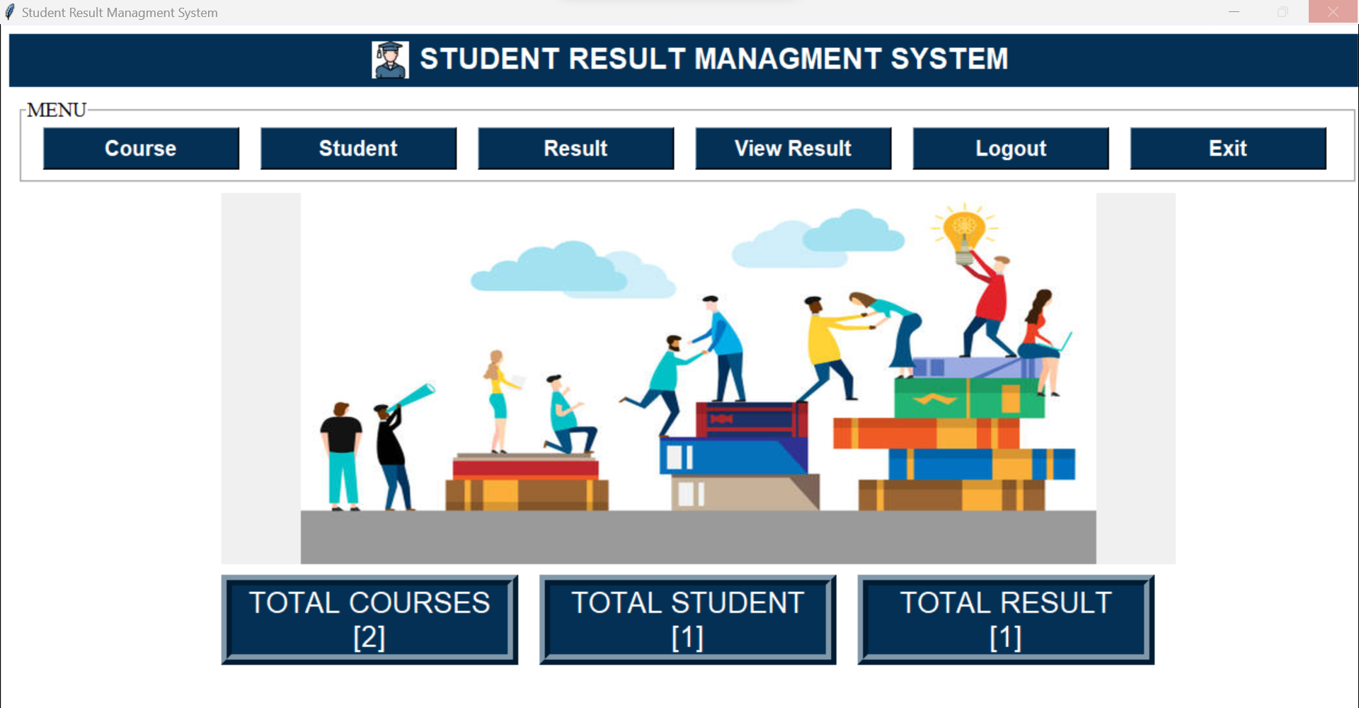

2.COURSE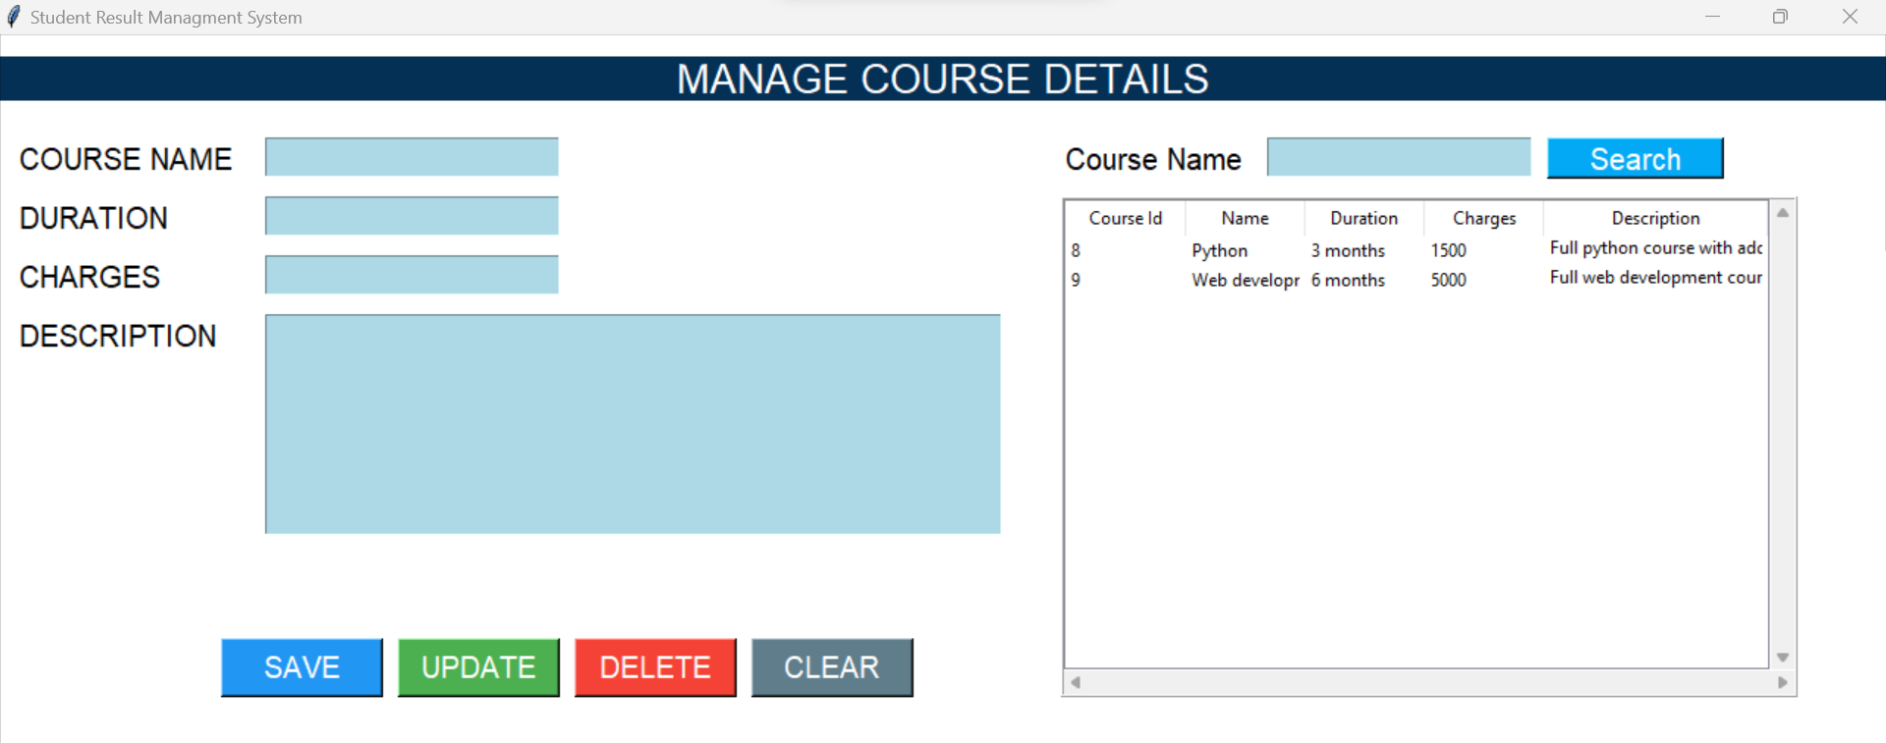

3.STUDENT

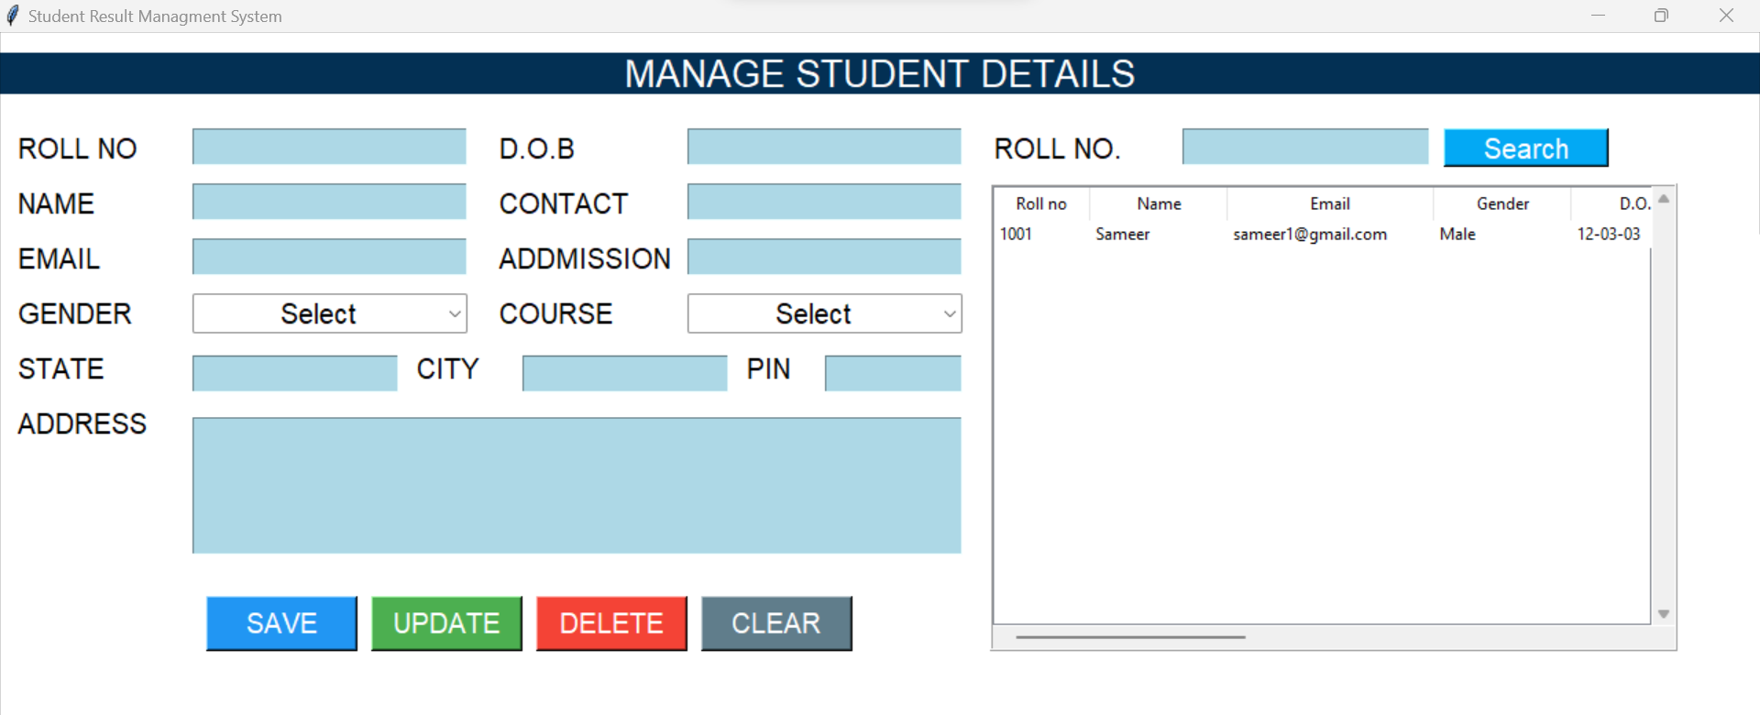

4.RESULT

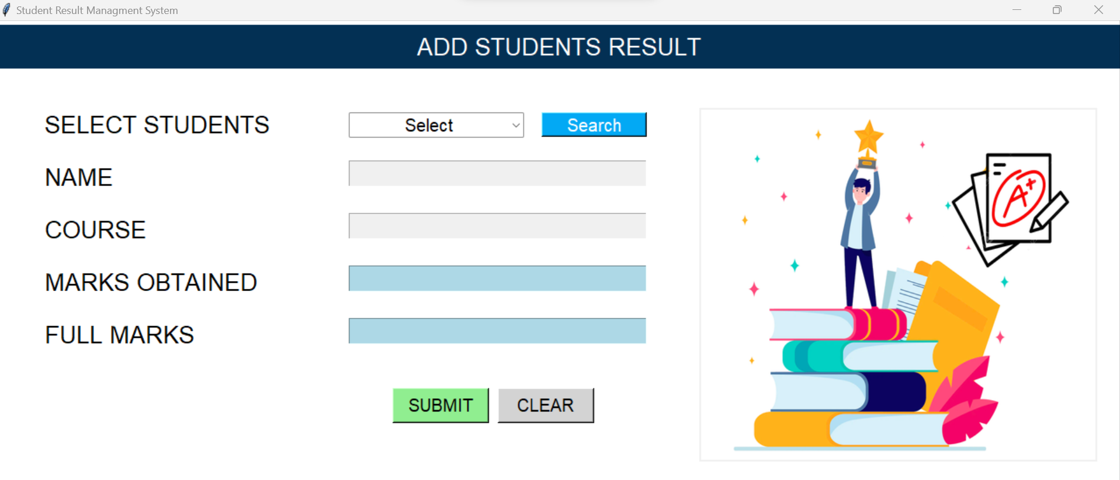

5.VIEW RESULT

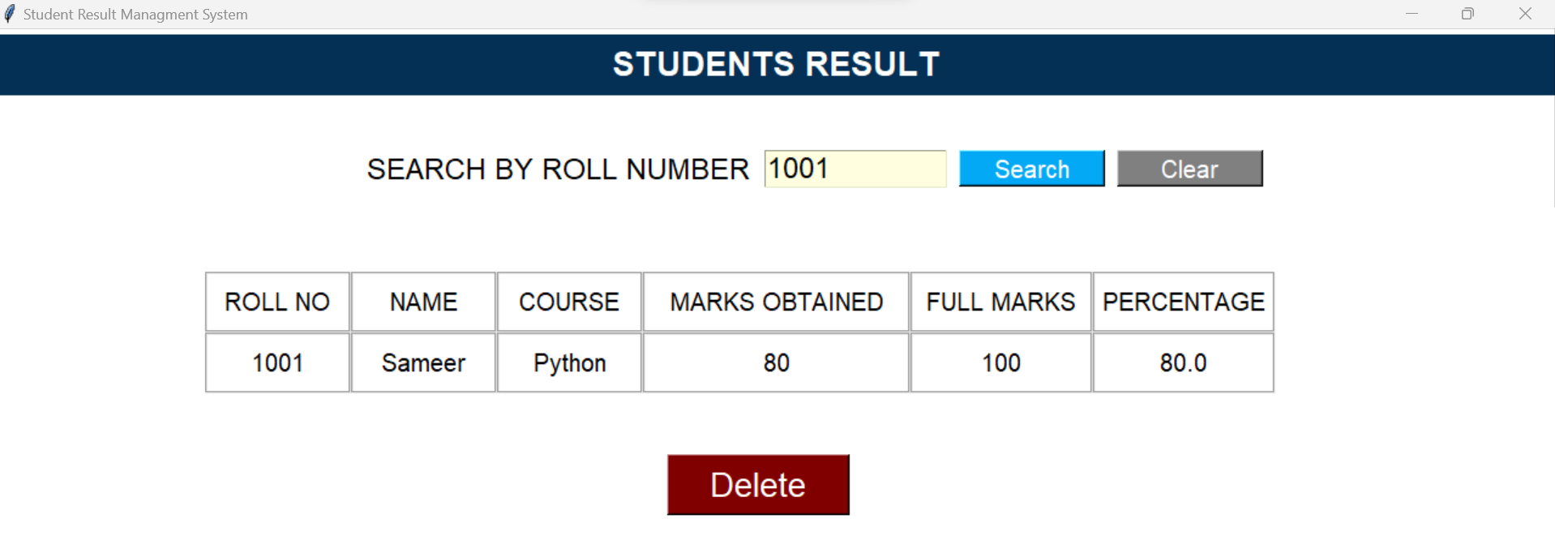

6.LOGIN

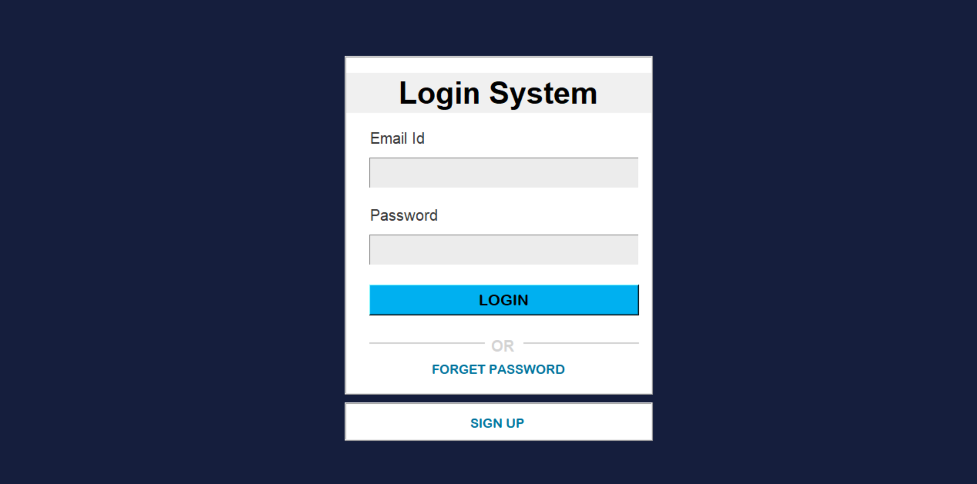

7.SIGN UP

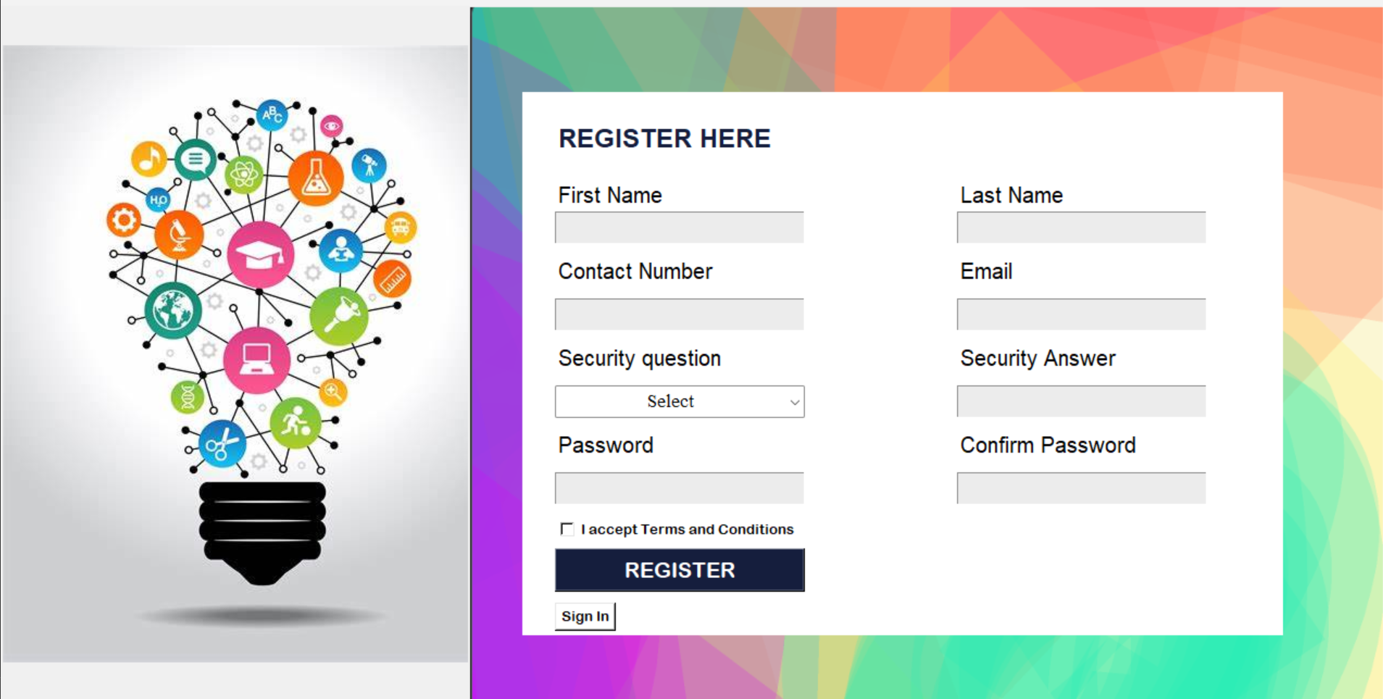

8.FORGOT PASSWORD

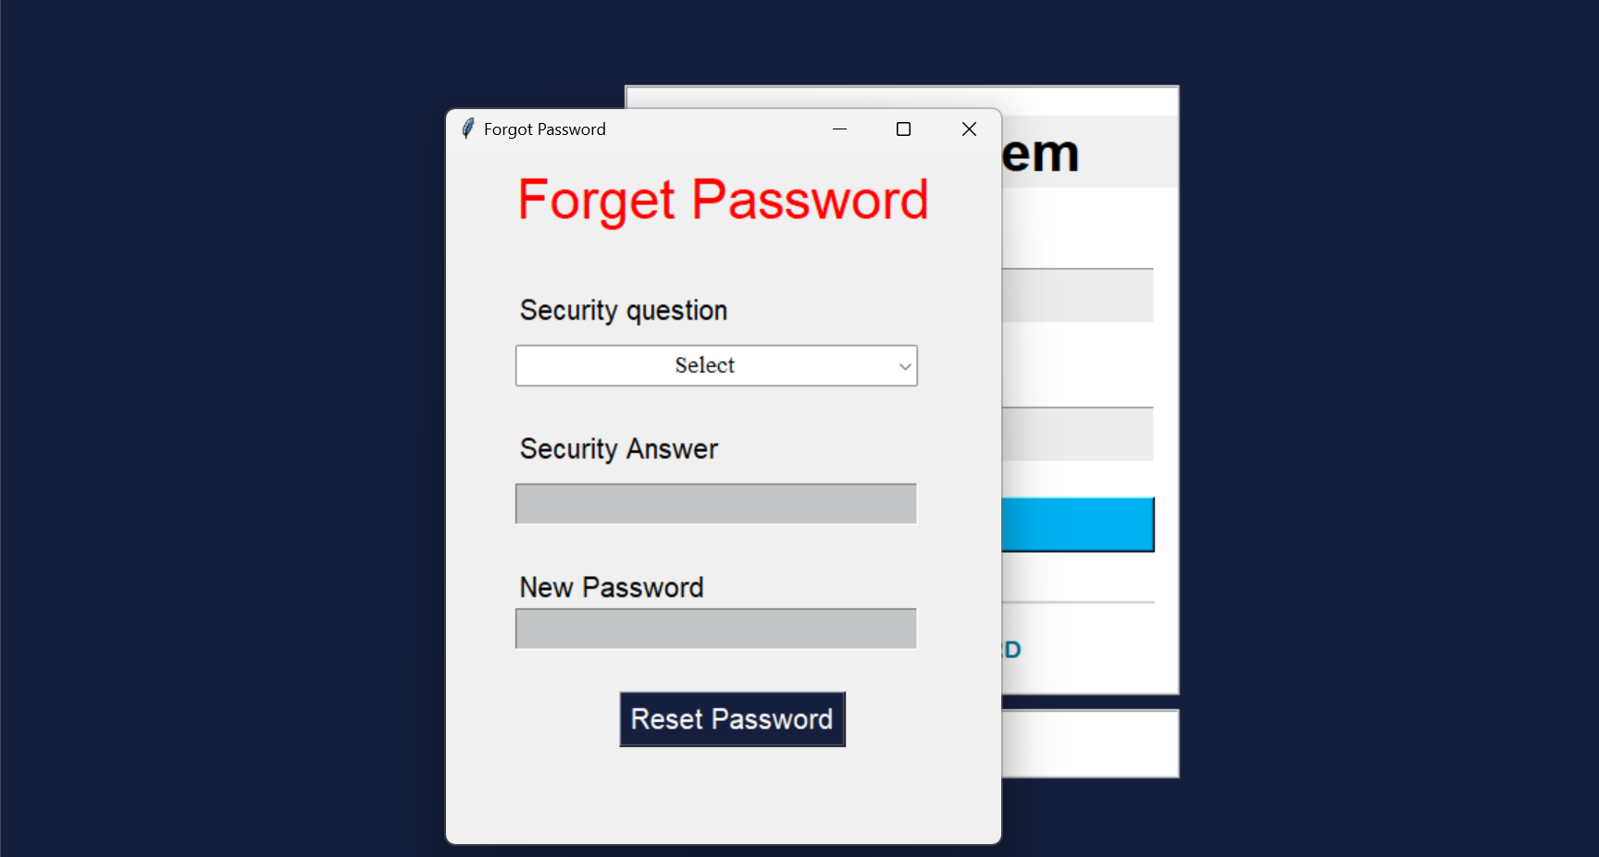

**FUTURE SCOPE**

* Allot seat to students in exam halls.
* Integrate-able with fee management.
* Generate printouts of examination and test reports instantly.
* Send/ publish results to parents and students online.
* Separate login for students for viewing their result and downloading in pdf form

**BIBLIOGRAPHY**

* <https://www.tutorialspoint.com/python/python_gui_programming.htm>
* <https://www.geeksforgeeks.org/python-pillow-a-fork-of-pil/>
* <https://www.geeksforgeeks.org/python-sqlite/#:~:text=Python%20SQLite3%20module%20is%20used,after%20the%202.5x%20version>.
* <https://www.w3schools.com/python/>
* <https://www.geeksforgeeks.org/python-sqlite/>
* <https://www.geeksforgeeks.org/python-classes-and-objects/>
* <https://www.geeksforgeeks.org/python-gui-tkinter/>
* <https://www.javatpoint.com/python-tkinter>